Name: Rahul Kumar Rajak

**Case Study 12: Create the following custom tables for Interactive/Search Help reporting.   
ZxxxxxxEMP , ZxxxxxxEmpColleg, ZxxxxxxAddress2 Where xxxxxx is your Empcode.**

**Solution:**

**Created the first Table Z46285397EMP.**

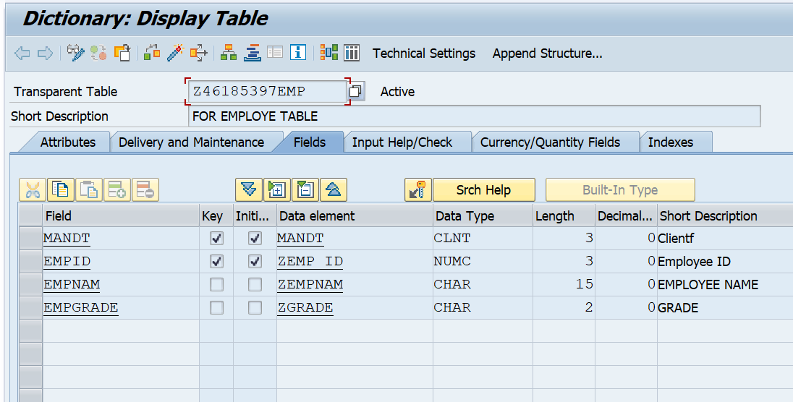

**Created the 2ND Table Z46285397EMPCOLG.**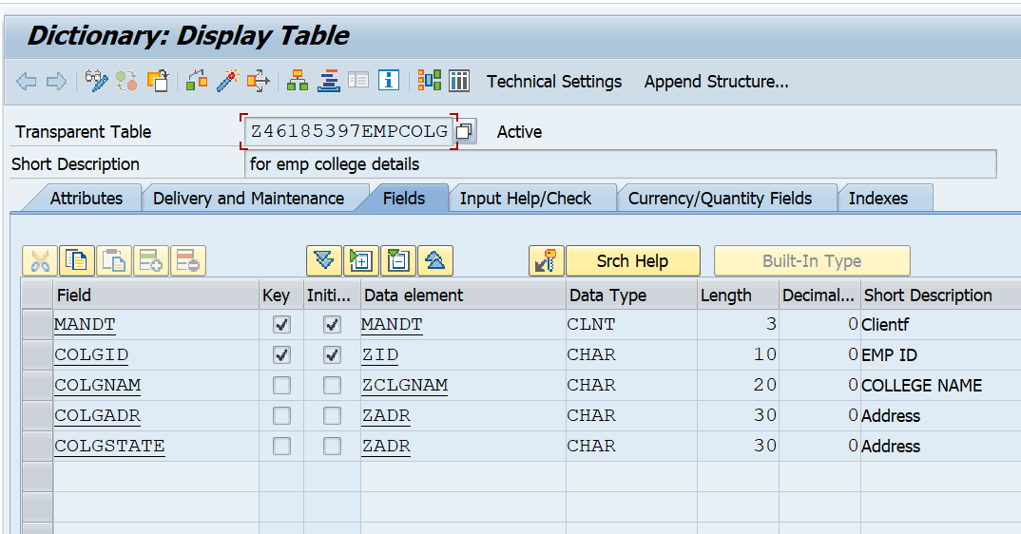

**Created the 3RD Table Z46285397EMPADS.e**

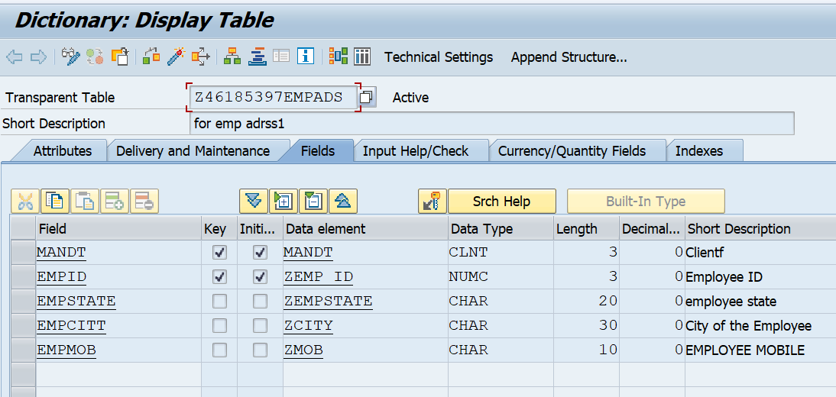**Created a view Z46185397_EMP.**

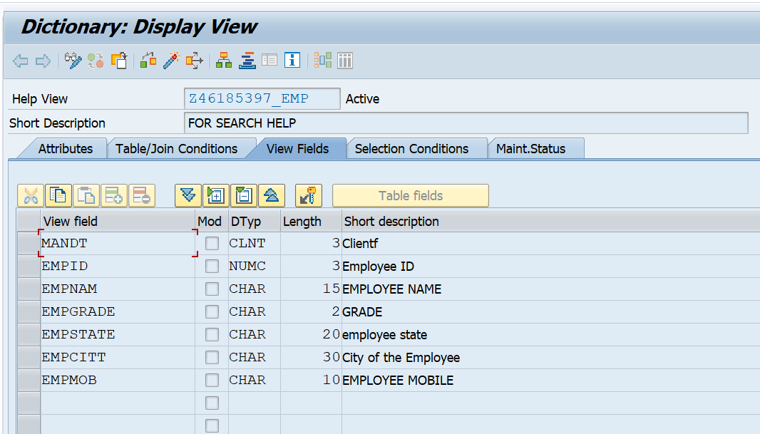

**Created SEARCH HELP Table Z46285397_EMP.**

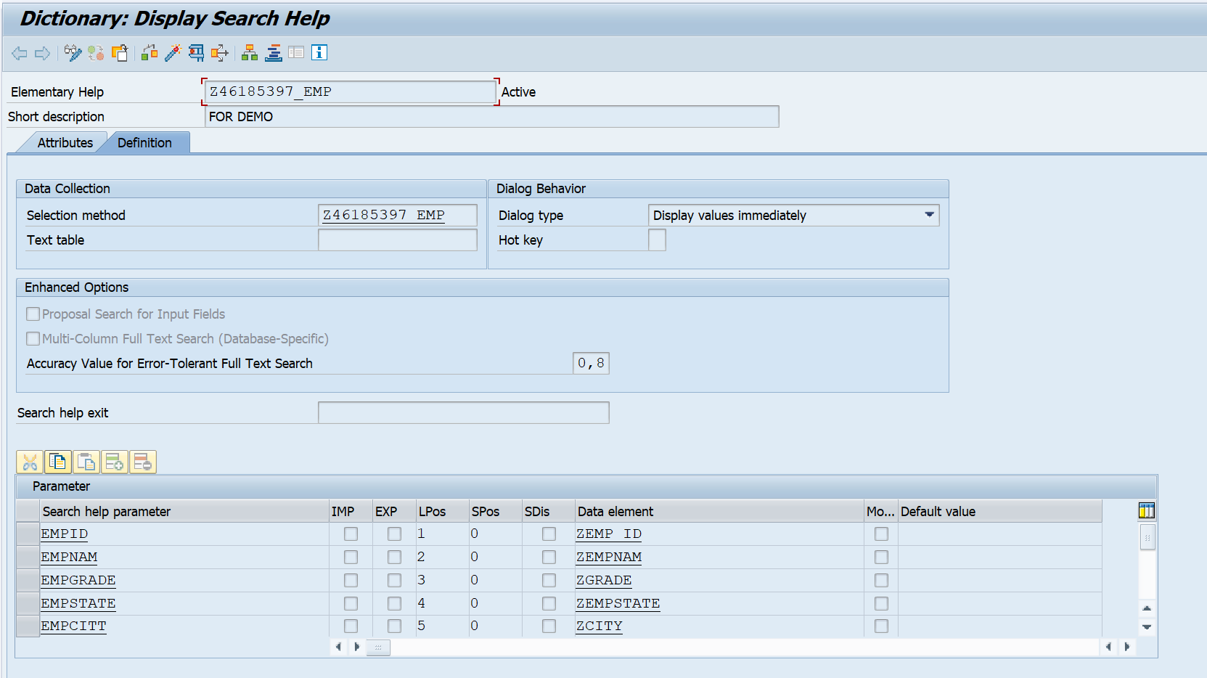

REPORT ZRAHUL_CS12.  
  
DATA:  
  LV_VALUE  TYPE HELP_INFO-FLDVALUE,  
  LT_RETURN TYPE STANDARD TABLE OF DDSHRETVAL.  
  
  
SELECTION-SCREEN BEGIN OF BLOCK B1 WITH FRAME TITLE TEXT-001.  
  
PARAMETERS : P_EMP TYPE Z46185397EMP-EMPID.  
  
SELECTION-SCREEN END OF BLOCK B1.  
  
AT SELECTION-SCREEN ON VALUE-REQUEST FOR P_EMP.  
  
  CALL FUNCTION 'F4IF_FIELD_VALUE_REQUEST'  
    EXPORTING  
      TABNAME           = 'Z46285397EMP'     " Table/structure name from Dict  
      FIELDNAME         = '<EMPID>'     " Field name from Dictionary  
      SEARCHHELP        = 'Z46185397_EMP'      " Search help as screen field   
      VALUE             = LV_VALUE    " Field contents for F4 call  
    TABLES  
      RETURN_TAB        = LT_RETURN   " Return the selected value  
    EXCEPTIONS  
      FIELD_NOT_FOUND   = 1           " Field does not exist in the Dictionar  
      NO_HELP_FOR_FIELD = 2           " No F4 help is defined for the field  
      INCONSISTENT_HELP = 3           " F4 help for the field is inconsistent  
      NO_VALUES_FOUND   = 4           " No values found  
      OTHERS            = 5.  
  IF SY-SUBRC = 0.  
    READ TABLE LT_RETURN INTO DATA(LS_RET) INDEX 1.  
    P_EMP = LS_RET-FIELDVAL.  
**ENDIF.**

**RESULT:**

